



**Generalized Operational FLEXibility for Integrating   
Renewables in the Distribution Grid (GOFLEX)**

AAU Flex-Offer Manager User Manual, V3

**Jan, 2020**

#### **Introduction**

Flex-Offer Manager (FMAN) - is an ATP sub-system for aggregators, balance responsible parties (BRPs), micro-grid responsibles (MGRs), which allows managing (potentially large) collections of flexible loads in the Flex-Offer form. It integrates advanced Flex-Offer aggregation and disaggregation functionalities, optimization, as well as Graphical User Interface (GUI), which allows its users effectively and efficiently analyzing, trading, and shaping available flexibility in near real-time.

FMAN is an intermediate ATP sub-system that, in near real-time, collects Flex-Offers from one or multiple FOAs (Flex-Offer Agents), optimizes loads (Flex-Offers) for a specific user-defined optimization objective (e.g., demand-supply balancing), and trades flexibility on Flex-Offer Market (FMAR) based on available Flex-Offers. At the time of writing, FMAN is currently connected to a single FOA for TP-Link smart-plugs and the Swiss Cloud-IO; and a single FMAR system hosted by INEA.

FMAN manages two kinds of assets, *Prosumer Loads* and *Market Orders* (commitments), along with their associated costs. The collection of these assets constitute the *Aggregator’s portfolio*, which is continuously optimized by FMAN (and used to derive new FMAR trading bids).

* **Prosumer Loads:** Each Flex-Offer provided by a prosumer (directly or via FOA) incurs some monetary reward to be provided by an FMAN user (i.e., Flex-Offer consumer: aggregator, BRP,

MGR) to the prosumer (i.e., Flex-Offer provider). The amount of this reward is governed by a so-called *user contract*, established between the FO provider (prosumer) and FMAN user (e.g., aggregator), and may vary depending on, e.g., the total number of issued FOs, total amount of time or energy flexibility provided, etc. FMAN manages such user contracts, as well the actual rewards exchanged between the market actors.

* **Market Orders:** FMAN continuously generates and submits market bids to FMAR. Bids that get accepted on the market become firm *market orders (commitments)*. In addition to a monetary amount to be paid out by a market (FMAR) participant to an FMAN user (aggregator), such market orders define *schedules* , containing energy amounts that have to be collectively consumed or produced by all FMAN’s FO providers. Deviations from such schedules incur imbalances that, depending on a so-called *market contract,* may lead to FMAN user (aggregator) loses. FMAN manages such bids, market orders, market contracts, imbalances, and imbalance fees.

Thus, the FMAN user’s (aggregator’s) absolute profit can be expressed as the sum of market order gains (Gmarket ), market order imbalances (Cmarket) , rewards (or energy discounts) to be paid to Prosumers for issuing (and executing) their FOs (CFOS ) , and some other fixed costs (CFixed ):

$$AggregatorProfit= \sum{G_{Market}-\sum{C_{Market}-\sum{C_{FOS}-\sum{C_{Fixed}}}}}$$

FMAN gives flexibility to its users (aggregators) in defining the attributes of *user contracts* and *market contracts* and setting load *aggregation, optimization and trading* parameters, and so the system caneffectively be used in various demand-response scenarios across the GOFLEX demo sites and beyond.

For example, if aggregation is enabled and trading is disabled, in this configuration, FMAN can be used as a stand-alone demand-supply balancing tool for, potentially, a large number of loads (FOs) in a certain area (energy community, DSO area, or balance group).

The documented is divided into several sections. The first section details the initial configuration steps, while the remaining sections describe the important features that are available in GOFLEX FMAN.

#### **Initial Configuration**

* 1. First-time system sign-in

You must be a registered user to access the FMAN system. Initially, the system has a single pre-defined administrator user, whose username is “admin” and the password is “admin”. Please use this for your first login. However, we strongly recommend changing this default password in the user profile page, accessible from “Configuration > User Profile” or, alternatively, the top header.



In addition, we recommend setting your location, as described below.

* 1. Add Location

For proper rendering of users on the map, users have to provide their geographical locations. This can be done by navigating to the “Configuration > User Profile” page in the FMAN GUI (available in the side navigation panel). The page allows users to add/update the location among other things. The location can be added/modified by typing in the address box, selecting one of the suggestions, and clicking on the ‘**Update**’ button at the bottom of the form to complete the process. The location can also be set by directly clicking on the map, then clicking on the ‘**Update**’ button.



* 1. Creating additional user accounts

If multiple users need to access the system, a new user account can be created by the system administrator by opening the user-list page (“User > List”), clicking “Sign-up a new User”, and filling the sign-up form.



#### **The dashboard**

The dashboard is the default (main) FMAN page, showing the summary, live Key Performance Indicator

(KPI) values, and various time series that represents the active system state / portfolio.

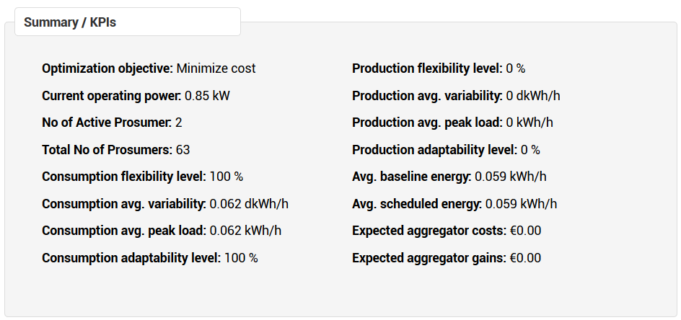

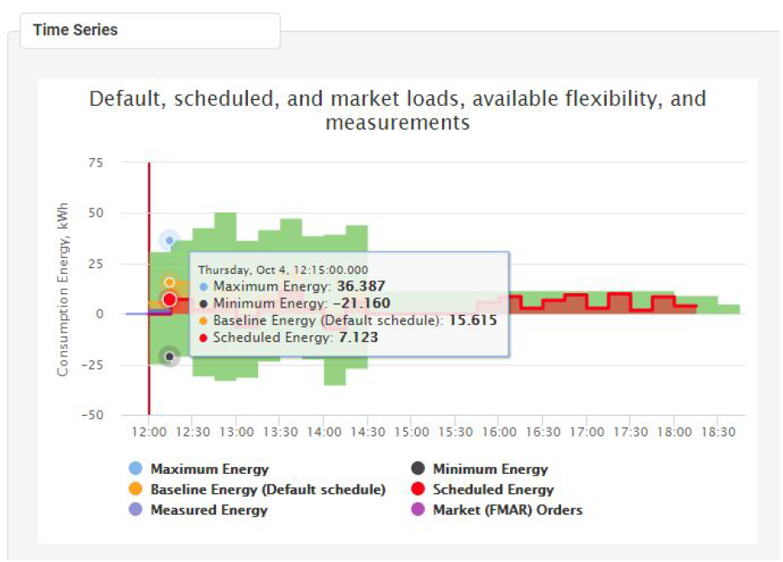

As seen in the figure, the dashboard shows basic information such as the current load optimization objective selected, number of active users, and the total number of users. The remaining numbers are

KPI values that characterize (summarize) the active aggregator portfolio: current consumption and production adaptability level, expected and scheduled energy amounts, as well as expected FMAN user gains and costs. The chart below shows aggregated both historical and expected future loads, separated by the vertical red line that represents the current time. Here, we distinguish between (1) baseline (default) user amounts, (2) optimized / scheduled (FO) amounts, (3) maximum and (4) minimum amounts realizable (schedulable) for specific time interval, (4) market order amounts, and (5) actual measurement amounts from prosumers.

Specifically, the presented KPI values cover the full (future) time interval of the active portfolio and have the following meanings:

**Consumption flexibility level** - this KPI characterizes the interval of time with flexible consumption. The value indicate a percentage of intervals (e.g., minutes) with flexible consumption (Flex-Offers) within the full period of the active portfolio.

**Consumption average variability** - this KPI characterizes the level to which the consumption can be varied by utilizing Flex-Offers in the active portfolio. It is computed by subtracting minimum energy values from maximum energy values (see Time Series), averaging resulting delta values, and then converting energy (/15min) to power (multiplying by 4). Note, this value is not defined (shown as zero) for time periods with no flexible consumption.

**Consumption average peak load** - this KPI characterizes average peak consumption, which can be realized by utilizing Flex-Offers in the active portfolio. It is computed by taking an average value of maximum energy (see Time Series) and converting it into power (multiplying by 4). Note, this value is not defined (shown as zero) for time periods with no flexible consumption.

**Consumption adaptability level -** this KPI characterizes the level to which the consumption can be varied with respect to the peak load by utilizing Flex-Offers in the active portfolio. This is the ratio between *Consumption average variability* and *Consumption average peak load*, shown as a percentage. Note, this value is not defined (shown as zero) for time periods with no flexible consumption.

**Production flexibility level, average variability, production average peak load, and production adaptability levels** are defined analog to the above (by taking only the negative instead of positive values of the Time Series chart).

**Average baseline energy -** this KPI characterizes average energy requested/offered by *Prosumes*, i.e., it is a sum of energy values of the default profiles of Prosumer Flex-Offers in the active portfolio.

**Average scheduled energy -** this KPI characterizes average energy requested by *the Aggregator* (e.g., due to FMAR requests and/or a selected optimization option), i.e., it is a sum of energy values of the schedule profiles of Prosumer Flex-Offers in the active portfolio.

**Expected aggregator costs -** this KPI characterizes total expected aggregator expenses. This corresponds to the market order imbalances (Cmarket), rewards (or energy discounts) to be paid to Prosumer for issuing (and executing) their FOs (CFOS ) , and some other fixed costs (CFixed ) in Equation 1 (see above).

**Expected market gains -** this KPI characterizes total expected aggregator gains. This corresponds to market order gains (G market ) in Equation 1 (see above).

#### **Users**

The users' page provides information about various types of users registered with the system (administrators, brokers, and prosumers) as well as their loads. It offers a map view as well as a list view as described below.

3.1. Users

The map visualizes the users on the map based on their geographical locations. Each user is represented by a red marker. Hovering mouse over a marker activates a pop-up window, showing the following information for the user:

* The username which can be clicked to navigate to the user’s profile page.
* The user’s location (latitude and longitude).
* A bill icon (the one on the left) which is essentially a link to the user’s bill page.
* A contract icon which is a link to the user’s contract page.

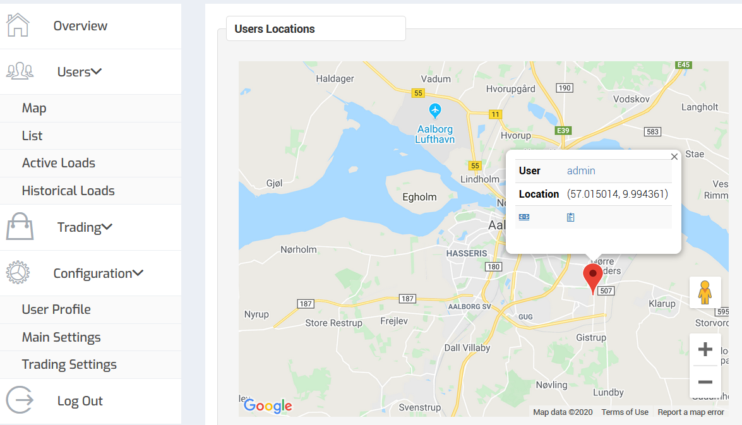

3.2. List View

The list view offers some extra information in addition to the above. Prosumers and system users are listed in separate sections. The “**actions”** column contains links to the user’s profile, bill, and contract pages. At the bottom of the page, there is a link to register a new user.

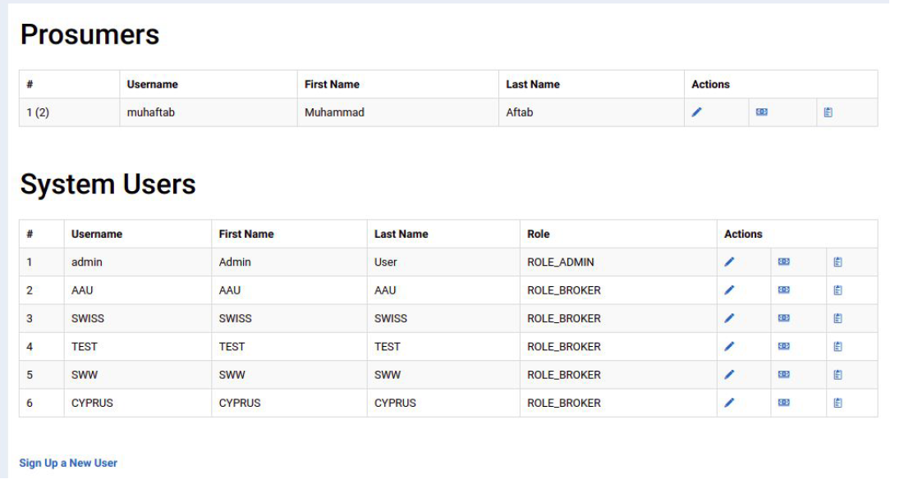

3.2.1 User Bill

As mentioned above, the bill page for a user can be navigated to by clicking on the bill icon on the map or in the list. Users can see total offered flexibility, assigned schedule deviations from the baseline (default schedule), and the resulting total reward. Users can also specify the month using the Date input box above the table.

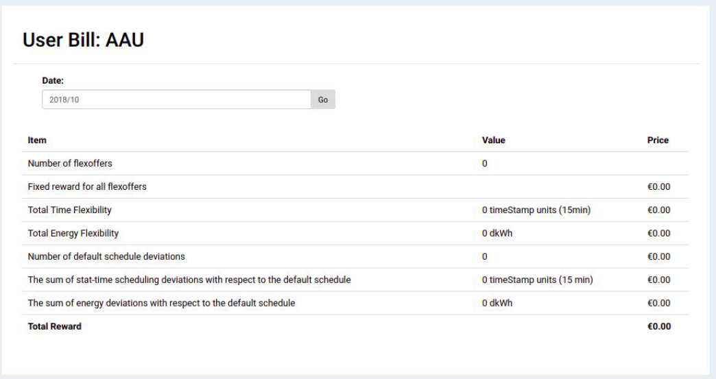

3.2.2 User Contract

The contract page shows the agreed contract between the prosumer and aggregator. The contract governs the rewards earned by the prosumers. The FMAN user (aggregator) can modify the terms of the contract and save the changes by clicking the “Update” button at the bottom.

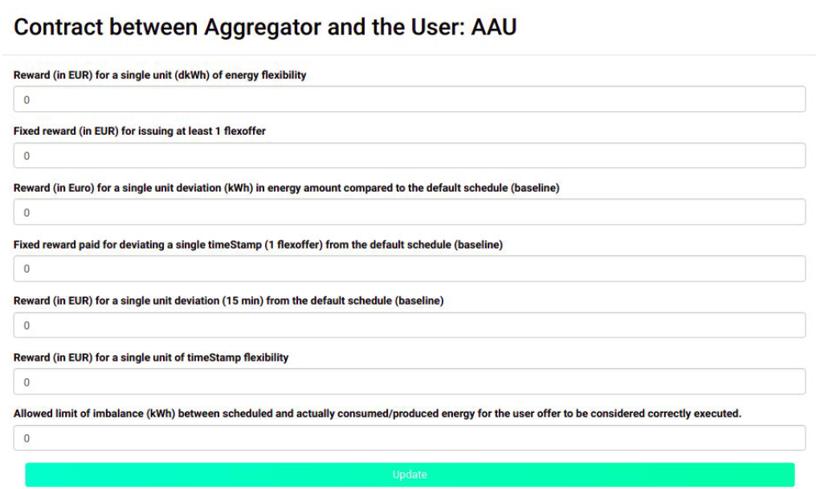

3.2.3. User Profile

User profile page is explained in Section 6.1.

3.3. Active Loads

The page shows the Flex-Offers received from prosumers, either directly or via Flex-Offer Agents (FOAs).

It shows the user Flex-Offers that are currently in an active state (INITIAL, ACCEPTED or ASSIGNED). The page offers a *tabular* view, *cost function* view, and *map* view which can be displayed by clicking on **“View As”** in the upper-right corner of the figure and choosing an appropriate item from the drop-down menu.

3.3. Historical Loads

Here, users can see all the historical Flex-Offers. Flex-Offers can be filtered by user, time period, and Flex-Offer states. The filtered Flex-Offers can be viewed in four different ways (each in a separate tab) as described below:

* **Aggregated view:** It shows the same information as shown in the Dashboard’s figure but for the currently filtered Flex-Offers only.



* **Map view:** It offers a geographic representation of the filtered Flex-Offers. Each Flex-Offer is shown as a red marker on the map. Hovering mouse over a marker shows the Flex-Offer details in a pop-up window.



* **Tabular view:** It offers a tabular representation of the filtered Flex-Offers.



* **Graphical view:** It offers a graphical view similar to Active Loads page.



#### **Trading**

This section describes the trading menu:

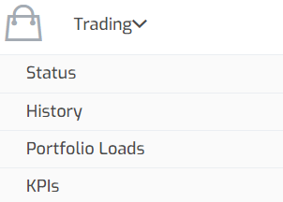

4.1. Status

The page summarizes both an active aggregator’s portfolio (the loads which are traded), as well as the last still active bid issued for trading.





As seen at the top of the figure, this page focuses on the financial aspects of the portfolio, i.e., the constituents of Equation 1: fixed losses/expenses, Flex-Offers costs, market order gains, market imbalance costs, and the total portfolio cost.

As seen at the bottom of the figure, this page shows details about the last issued bid: the time when the bid was issued (transaction time), trading interval, bid-offer status, Id of the offer in the FMAR system.

As a bid offer is represented by a Flex-Offer, different options to analyze this bid offer are provided. In the figure, the activated “Cost functions” view shows the relationship between bid amounts (expected gains, in EUR) and different realizations of available flexibility with respect to the default (baseline) schedule (0.0 amount on the X-axis).

4.2. History

This page allows analyzing all market orders, as well as all other market transaction (bids) issued in the selected time interval. For each market order, it shows bid issuing time (transaction time), FMAR Id, requested deviations from the balance (a market schedule), as well as expected gains for fulfilling the market order. If sufficient power measurement data is available (from prosumers, FOAs), market orders can be successfully validated and the factual market order imbalances and gains can be computed.



4.2. Portfolio Loads

This page displays flexible loads (FlexOffers) that take part of the active portfolio, i.e., these loads are used for bid generation / trading. This list contains either original prosumer FlexOffers (if aggregation is disabled) or FlexOffers after aggregation (if aggregation is enabled).

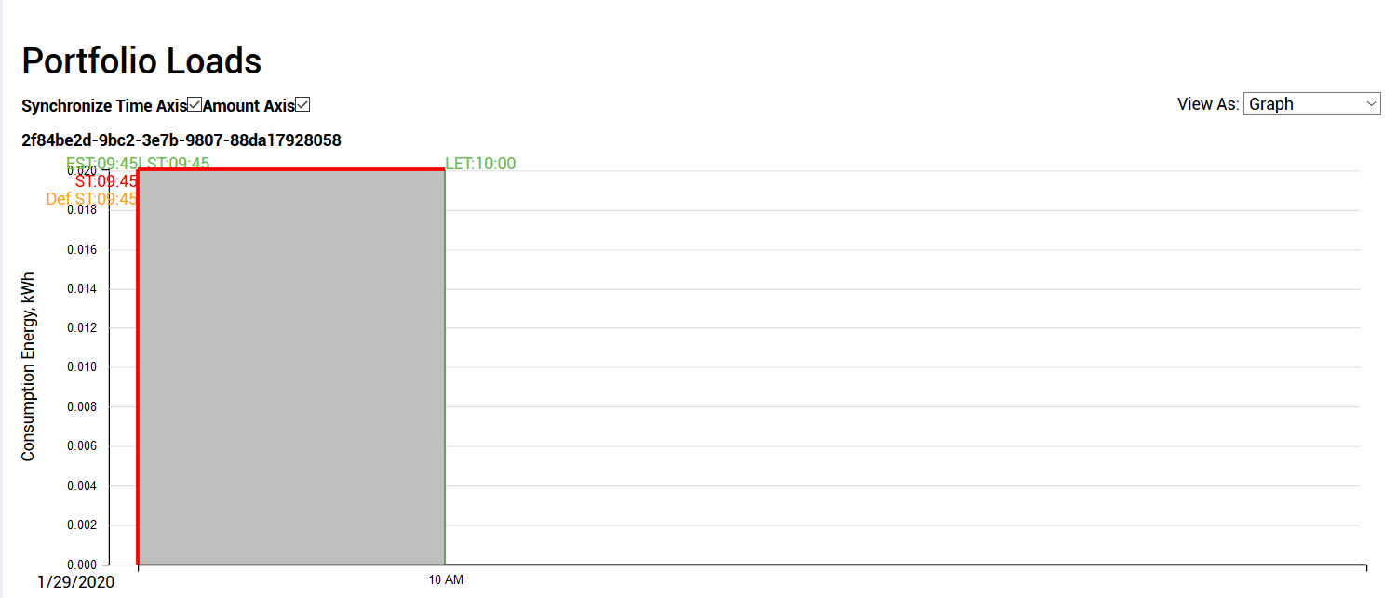

4.2. Key Performance Indicators (KPIs)

The page allows retrieving a history of KPI values for a selected time period, either for all users or a selected specific user. Essentially, the KPIs presented in Section 2 are displayed, however the values of these KPIs are computed for a selected historical time period.

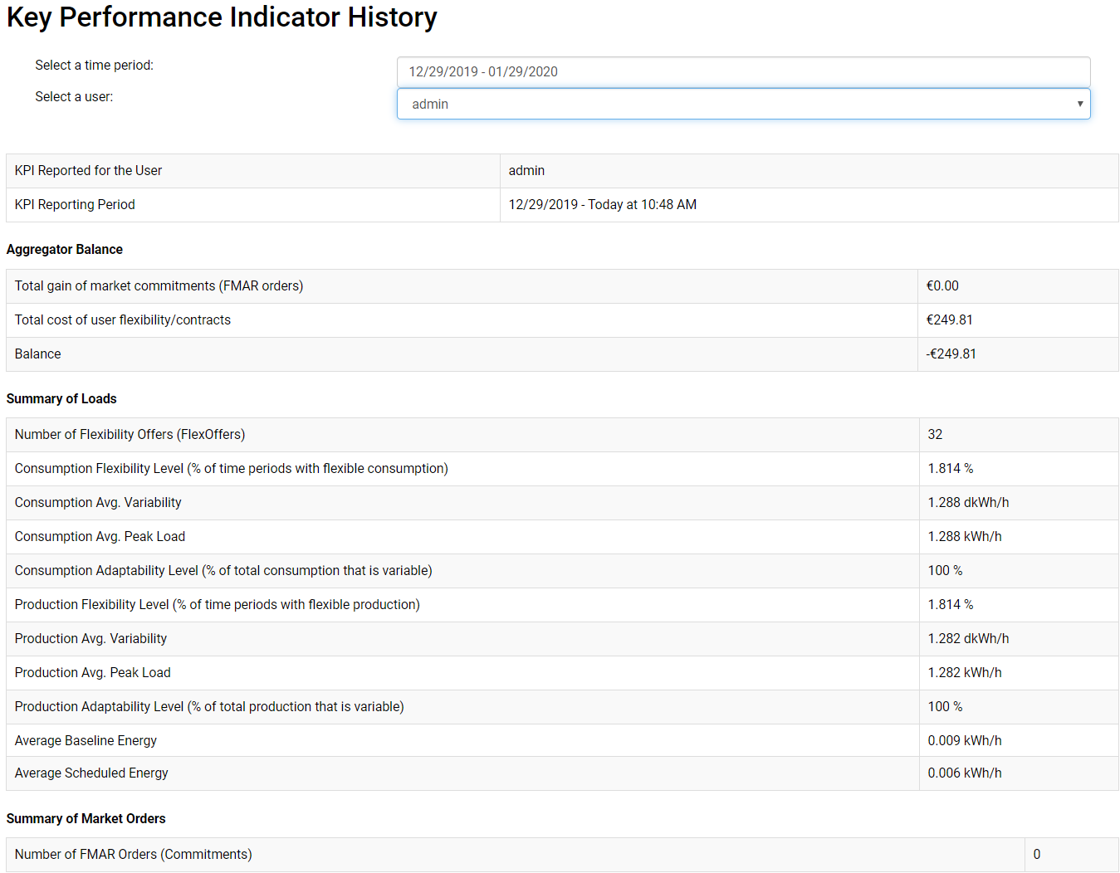

#### Configuration

5.1 User profile

Here, users can update their account details and location. In addition, Administrators can also assign a different role (i.e., ADMIN, PROSUMER, BROKER) to a user or disable the user altogether. The bottom of the page provides the option to delete the user.

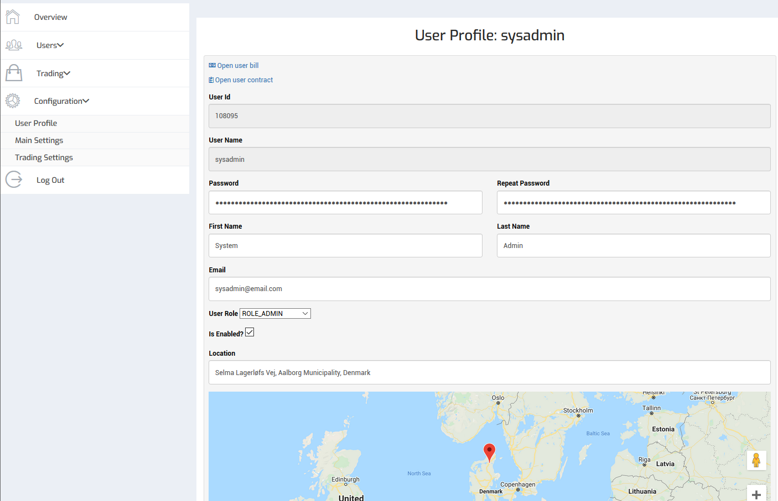

5.2 Main Settings

This page offers access to the essential parameters of FMAN. First, in this page, the user can toggle load

(FO) aggregation, which significantly increases optimization performance, both in execution time and solution quality, for a larger number of loads (FOs, >>20). Second, on this page, the user can enable or disable trading with Flexibility Market (FMAR). Finally, the user can select the desired load optimization objective, which will optimize loads (FOs) either for demand-supply balancing, cost minimization, FMAR order execution, energy minimization, or maximization in a user-specified time period.

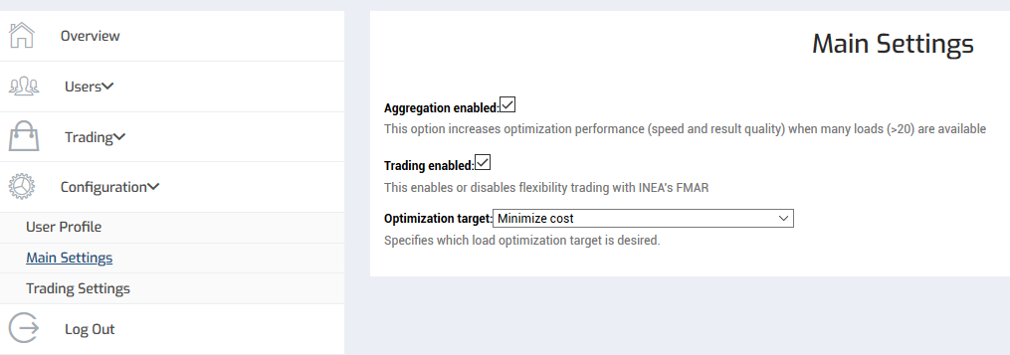

5.3 Trading Settings

In this page, the user can enable or disable FMAR trading, as well as set and/or fine-tune specific bid generation parameters:

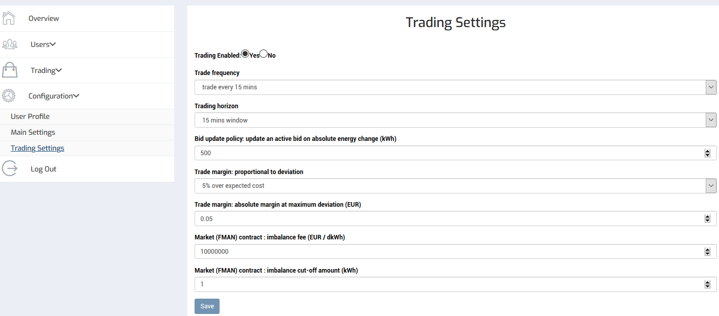

* **Trade frequency**

This parameter defines the frequency at which new FMAR bids (orders) are generated. Note, FMAR allows submitted bids/orders to be updated, either until latest possible load (FO) assignment time or until the market schedule is generated by FMAR and delivered to FMAN (a bid becomes the market order). The frequency of such bid updates is controlled by “bid update policy” parameter, described below.

* **Trading horizon**

This parameter defines the trading horizon, i.e., the time interval covered by a single bid order. It must be a multiple of 15 mins, leading to bid orders with a number of slices matching respective 15 min intervals.

* **Bid update policy: update an active bid on absolute energy change (kWh)**

This parameter defines a condition to trigger a bid update - to better position the FMAN’s bid/offer when changes in the FMAN portfolio occur. It specifies the energy amount (in kWh) the two market offers - old (already submitted to FMAR) and new (an update) are allowed to differ on their MIN/MAX energy bounds to trigger the update. Note, FMAR allows such updates either until a schedule is generated, or load (FO) assignments are no longer possible (execution need to take place).

* **Trade margin: proportional to deviation**

FMAR automatically computes market order/bid prices by taking into account portfolio's costs incurred by scheduling of user loads according to (expected) market order schedules. This parameter allows further increasing (or reducing) bid prices proportionally to the requested deviation from the baseline, e.g., to increase FMAN user profit. Note, the value of 1 of this parameter will lead to bids barely covering actual load (FO) scheduling costs.

* **Trade margin: absolute margin at maximum deviation**

Like the previous parameter, this parameter specified absolute margin (in EUR) on top of the portfolio prices to calculate flexibility prices in bid offers. The effect of both the proportional (relative) and absolute margins to the ultimate bid offer prices are visualized as follows:



* **Market (FMAN) contract: imbalance fee**

This parameter specifies imbalance fee (Eur/kWh) for each kWh of imbalance energy, i.e., deviation between market order and actually consumed and/or produced energy amounts. Note, at the moment of writing, FMAR does not apply any imbalance fees. However, higher values of this parameter lead to the increased prioritization of market orders during load optimization. If such prioritization of market orders is desired, the value of this parameter has to be set to a very large number (100.000EUR/kWh). Note, specific values of these parameters have to be tuned for a specific FMAR instance and/or configuration, as well as expected conditions and participants on FMAR.

* **Market (FMAN) contract : imbalance cut-off amount (kWh)**

This parameter specifies the maximum allowed imbalance amount (kWh) from which the imbalance fee is applicable. I.e., if the factual imbalance is below this threshold, no imbalance cost will be incurred; only imbalance amounts exceeding this threshold are subject to the imbalance fee.